UAT Plan

for

Tilt Rush

Index

1. Scope 3

1.1. Objectives and business requirements 3

1.2. Scope 3

2. Testing team 4

3. Environmental requirements 5

3.1. Hardware requirements 5

3.2. Software requirements 5

4. Test Scripts 1

# Scope

## Objectives and business requirements

In this section, outline the business requirements. In other words:

* What are our goals? What are we hoping to accomplish with this project/feature?
* How will we measure success?

This sprint will be the first to add the gameplay to the app with the Device Orientation Events API. The basic framing for the play option will be made such as the score display and the pause menu, which will include resume and quit buttons. The ball will also be loaded in with the Canvas API and will then be able to move around the screen when tilting the screen.

## Scope

In this section, outline the scope. This means:

* What is the pain point we’re trying to fix?
* What are we testing exactly, and what are we *not* testing?

This sprint is to set the game up to have proper gameplay with future sprints, by finishing all the menuing and setting up the framework in the code for the player to be able to interact with the screen, and for the Canvas to draw all the elements.

This will not include any gameplay objects besides the player, including the spike, wall, goal, or mine. While the score display will be set up, as there is no goal, the score will not be updated or added to the stats page.

## System Diagrams

In this section, paste any drawings or diagrams that help the UAT team understand the program being tested. With each drawing include a brief explanation of how the drawing represents the application or system being tested.

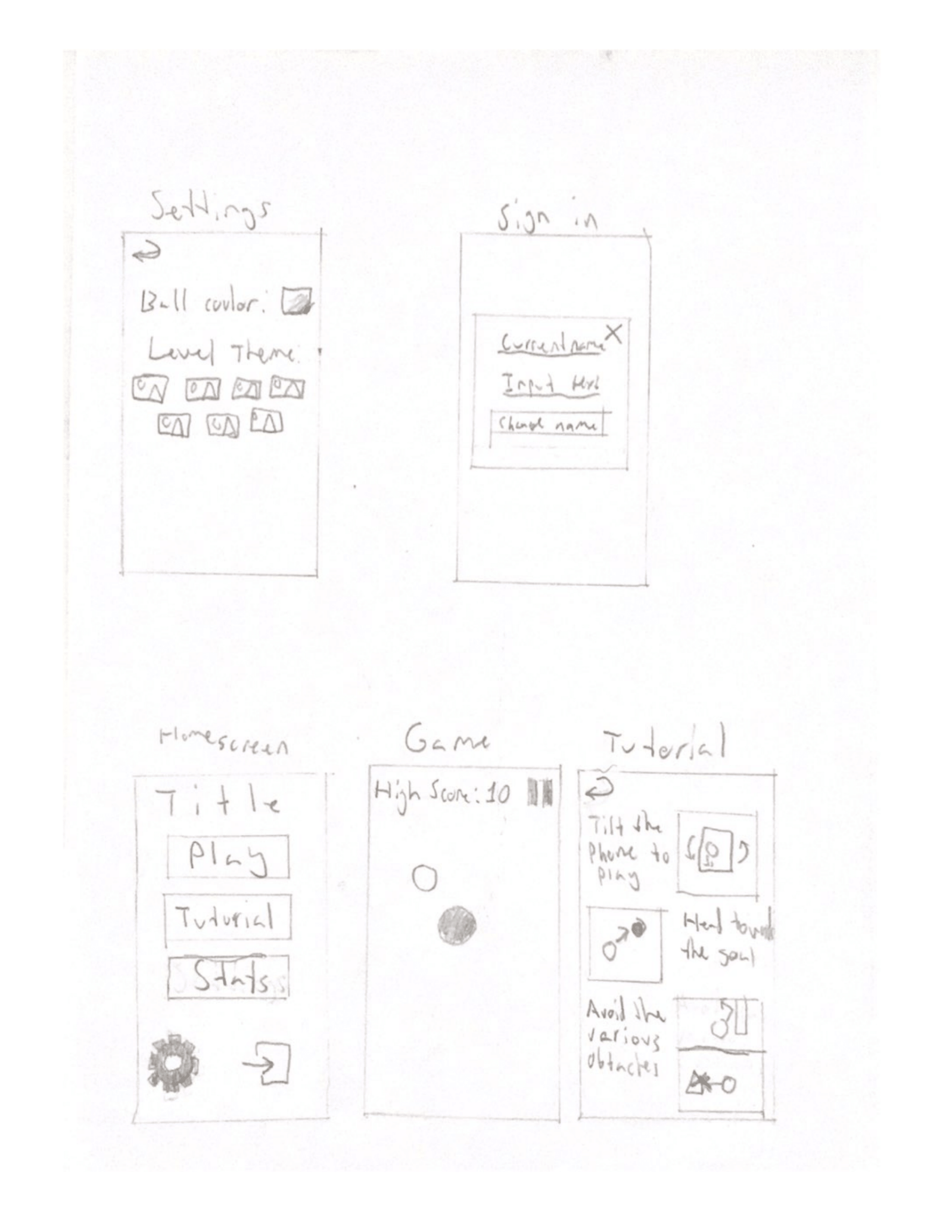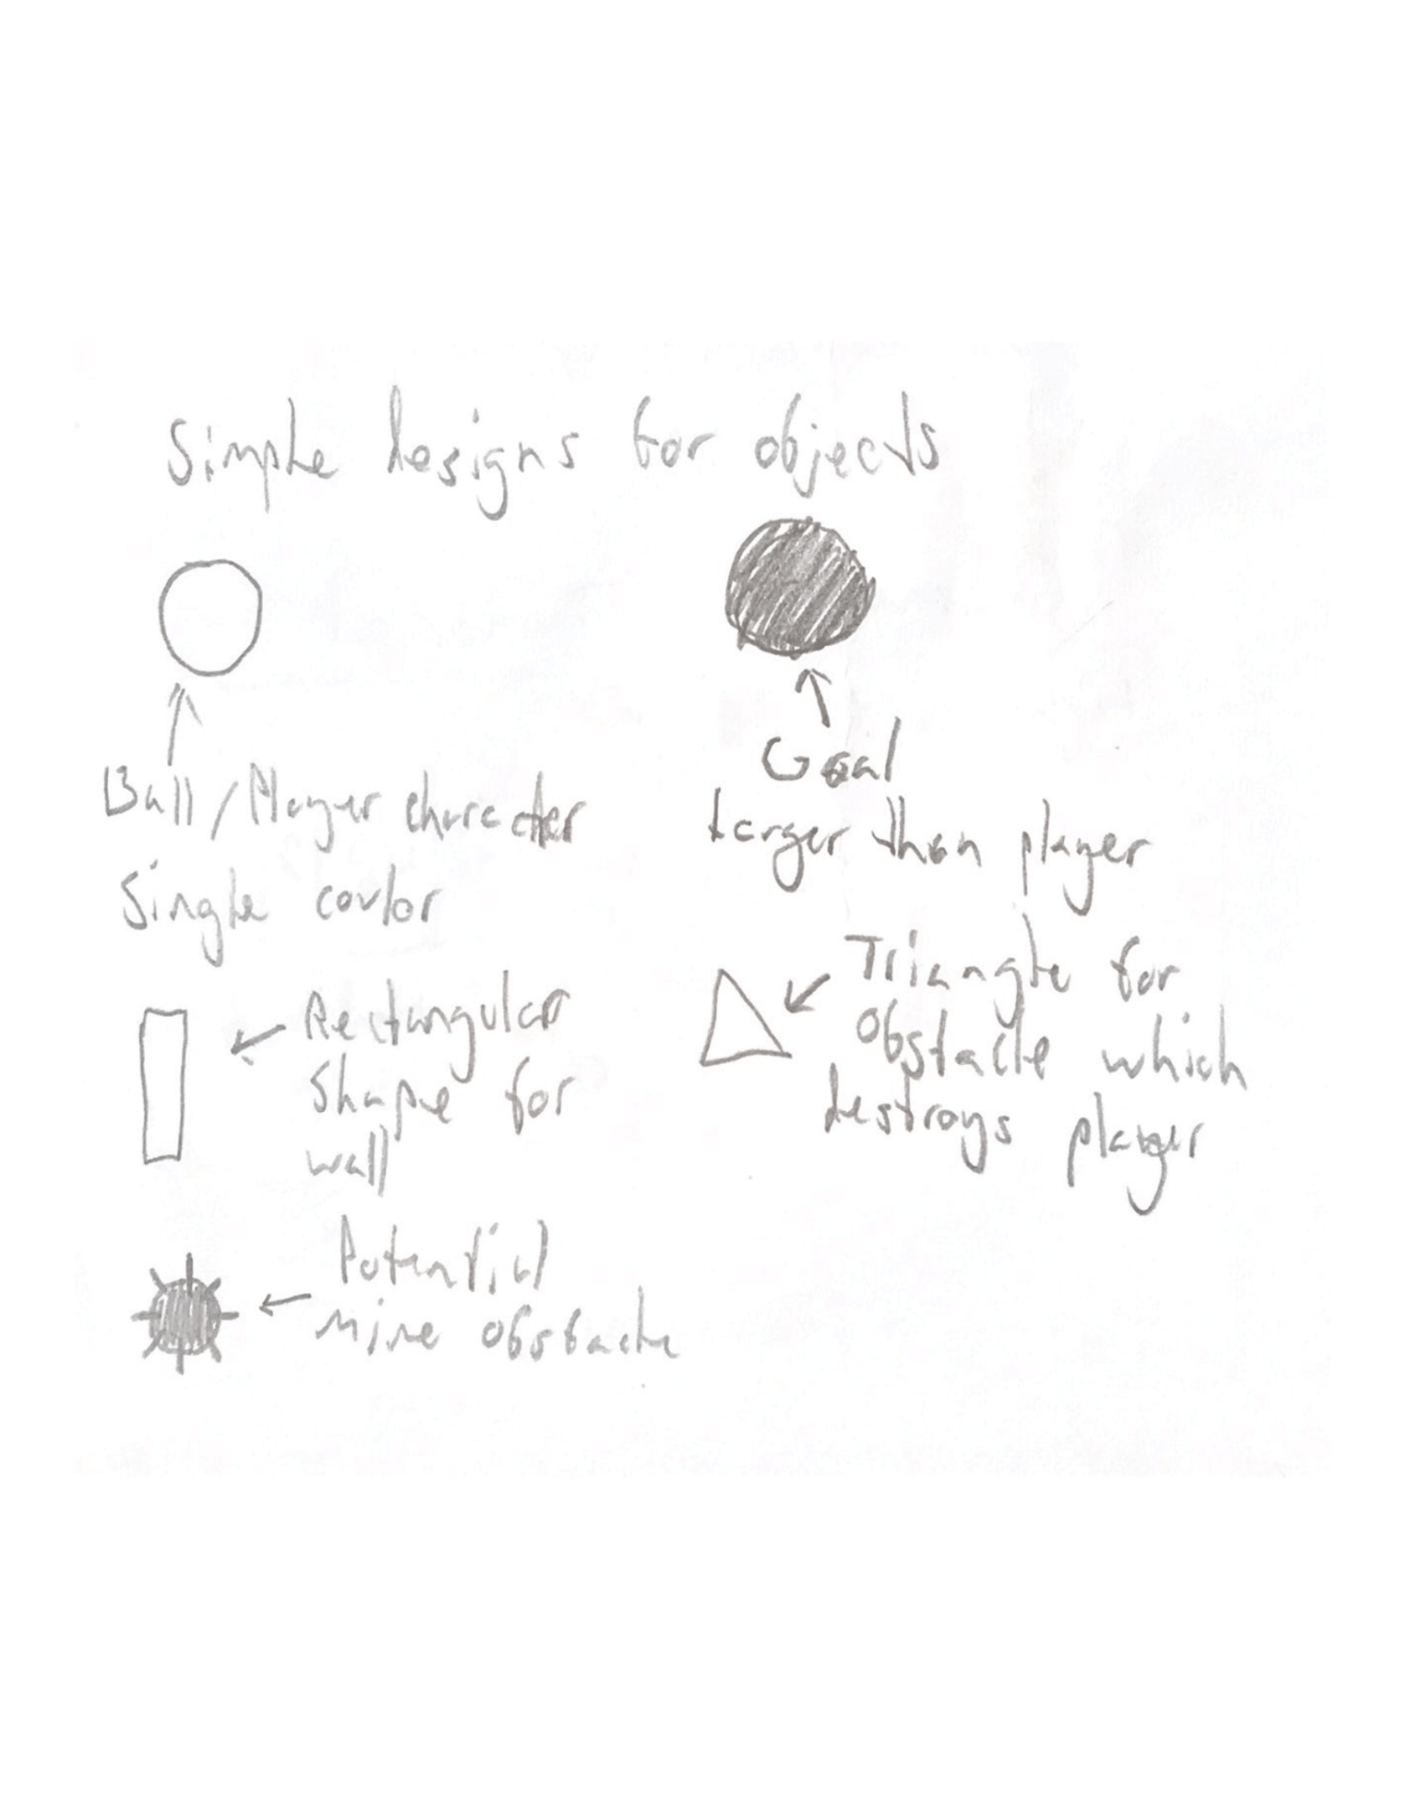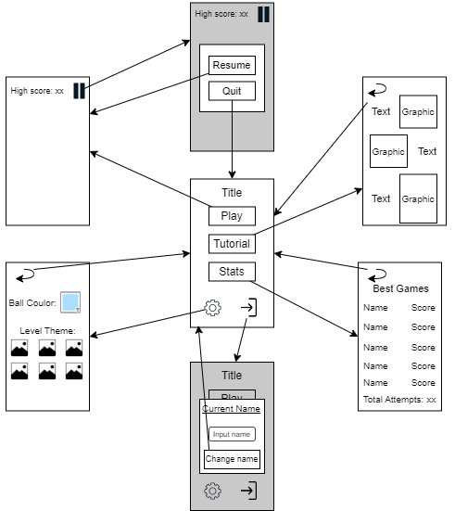

# Testing team

In this section, list out members of your QA team and what their roles will be during UAT.

Example:

| **Name** | **Responsibilities** |
| --- | --- |
| Areesh Khan | To test the menus between the homescreen and the play screen, and the current gameplay. |
| Lachlan Ng | To test the menus between the homescreen and the play screen, the current gameplay, and the initial colours when loading the app. |

# Environmental requirements

## Hardware requirements

What hardware has the solution been designed for and should be tested on.

If that is the case, outline the minimal and recommended requirements so the QA team can verify that the software runs on the testers’ machines.

Phone with online capabilities.

## Software requirements

If any extra software or dependencies must be downloaded and installed, list them here.

* Google Chrome (or similar browser)

## Network requirements

Some software (design, video editing…) can be demanding on hardware specifications.

If that is the case, outline the minimal and recommended requirements so the QA team can verify that the software runs on the testers’ machines.

* Working internet connection

# Test Scripts

This section is more important than it seems—it is crucial that both the QA team and the testers know what features must be tested, especially if you’re testing a lot at once.

| **Test** | **Describe the feature being tested** | **Describe the user input or test data** | **Describe the pass criteria** |  |
| --- | --- | --- | --- | --- |
| 4.1 | Play Page | 1. Open app 2. Press “play” button | 1. Game screen is loaded with ball 2. Score display shows 0 3. Pause button is there | Tester name: Areesh Khan   | 🗸 | PASS | | --- | --- | |  | FAIL |   Observations:  The play ‘play’ button functions as intended.  Tester name: Lachlan Ng   | 🗸 | PASS | | --- | --- | |  | FAIL |   Observations:  Functions of buttons acted smoothly on my phone. |
| 4.2 | Pause Menu | 1. Press pause button 2. Press resume 3. Press quit | 1. Pause button opens menu 2. Gameplay stops when menu is open 3. Resume goes back to gameplay 4. Quit goes to homescreen | Tester name: Areesh Khan   | 🗸 | PASS | | --- | --- | |  | FAIL |   Observations:  The pause, resume and quit buttons work appropriately and have a quick response time.  Tester name: Lachlan Ng   | 🗸 | PASS | | --- | --- | |  | FAIL |   Observations:  Yes it works very smoothly and quickly. |
| 4.3 | Player Movement | 1. If on iOS, go to settings and click the “iOS support” button 2. Tilt the screen in various directions and various angles 3. Bring ball to each edge of the screen | 1. The ball moves in differing directions corresponding to where and by how much the phone is tilted 2. Ball is stopped by the edges of the screen 3. Ball bounces of the edges based on the speed it hits with | Tester name: Areesh Khan   | 🗸 | PASS | | --- | --- | |  | FAIL |   Observations:  The gyroscopic features work as expected with proper tilt mechanics and with high precision.  Tester name: Lachlan Ng   | 🗸 | PASS | | --- | --- | |  | FAIL |   Observations:  I did not know where the ball rotating was calibrated to and when it was calibrated. Give a recalibration feature. |
| 4.4 | Loading Colours | 1. Choose a colour other than the first option in settings 2. Reload page and look at the first few moments | 1. The app loads in black first rather than the default colour | Tester name: Lachlan Ng   | 🗸 | PASS | | --- | --- | |  | FAIL |   Observations:  Yes. |

Write step-by-step, detailed but concise instructions on how to test the feature.